**Logic Design:**

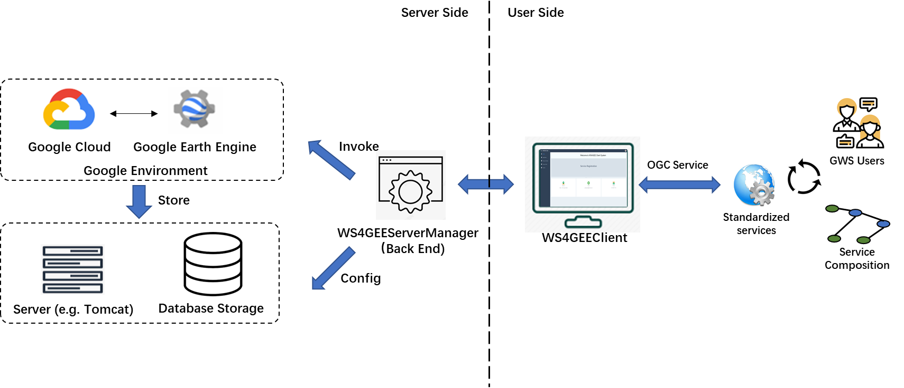

**Brief Description:**

WS4GEE Server Manager provides the environment to parse OGC request that are created from GWS users from the client side to executable GEE scripts through a list of process (e.g., mapping, validation, transformation). The transformed script will be past to the Google Earth Engine and then the result either sends to the Google Cloud Storage (GCS) or directly to the local database (e.g. MySQL) storages, which depends on the services type and the sizes of the result. Downloaded files can be managed by file system in order to realize cache strategy for efficiency.

The WS4GEEServerManager is built upon Django framework, which is commonly used in Python environment for backend development. It is responsible for the connection to Google Environment as well as local environment to execute transformed service scripts, achieve results, parse OGC requests and generate OGC response, etc.

**Reference:**

The development of the sever side of WS4GEE, mainly about the WS4GEEServerManager, is the integrated application of several technologies. This WS4GEEManager prototype just one of the realization to the target. Our implementation is described in the research paper in detail. Anyone who are interested in the development of the system can refer to our codes ,the reference, as well as the official documentations for relative technologies.

Available research paper for WS4GEE project: release soon.

Available codes for WS4GEEManager: <https://github.com/GenuineJianyuan/WS4GEEServerManager.git>

Django: <https://docs.djangoproject.com/en/3.2/>

Google Earth Engine (Python): (1) <https://developers.google.com/earth-engine/guides>; (2) <https://cloud.google.com/cli>; (3) <https://geemap.org>

Google Cloud: https://cloud.google.com/free/docs/free-cloud-features